**4 . RESONANCE IN A FORCED OSCILLATOR**

* 1. **AIM**

1. To determine the resonance frequency of a forced damped oscillator.
2. To investigate resonance in the various media.
   1. **PRINCIPLE**

When a spring mass system is driven by an external sinusoidal force, the amplitude of oscillation is given by-

$$A\left(ω\right)=\frac{F}{m\sqrt{{\left(ω^{2}-ω_{0}^{2}\right)}^{2}+ ω^{2}}γ^{2}}$$

Where

F – amplitude of the driving force

m- mass of the sscilator

- natural frequency of the oscillator

$γ$– Damping constant

When the frequency of the external driving force is close to the natural frequency of the oscillator, it uhas a maximum amplitude. This phenomenon is referred to as resonance and the frequency at which this occurs is known as resonance frequency of the oscillator.

**Change the frequency of the external force and measure the amplitude of the oscillatory motion.**

* 1. **EQUIPMENTS REQUIRED**

Table I :Equipment and the items required for performing the experiment.

|  |  |  |
| --- | --- | --- |
| **S. No.** | **Required item** | **Utility** |
| 1 | Digital sensor | To see the frequency at which the wheel is driven |
| 2 | Mass with rod | Body which oscillates. |
| 3 | Clear acrylic cylinder | To see the oscillating mass |
| 4 | Driving wheel | Source of oscillations |
| 5 | Magnetic scale | To measure amplitude |
| 6 | Spring | Propagation of oscillations |
| 7 | Water/oil/ | Medium of damping |

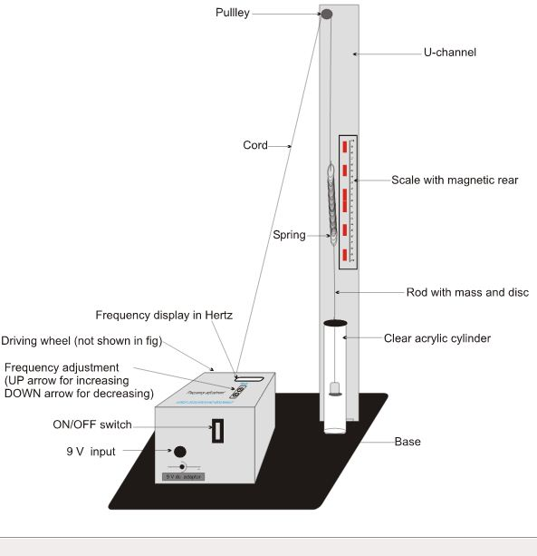

Figure 1: Photograph of the forced harmonic oscillator

* 1. **PROCEDURE**

Table II : The details of the physical quantities to be measured.

|  |  |  |  |  |  |  |
| --- | --- | --- | --- | --- | --- | --- |
| S.No | Physical quantity | Independent /  Dependent | Measured  with | Measuring instrument’s | | |
| Minimum | Maximum | Least count |
| 1 | Mass | Independent |  |  |  |  |
| 2 | Extension | dependent |  |  |  |  |
| 3 | Frequency | Independent |  |  |  |  |

1. First, measure the spring constant of the spring. (Remember Ist semester experiment).

Take readings in table III.

1. Attach the free end of the spring to the thread and pass it over the pulley.
2. Unscrew the disc attached to the rod and pass it through the lid of the clear acrylic cylinder. Attach 50gm weight to the rod. Now, screw the disc to its position.
3. Fill the cylinder with clear water to a level just below the brim and close the lid.
4. Place the scale (with magnetic rear) just behind the cylinder and see the scale through the cylinder. The scale appears to be magnified. If needed adust the scale vertically or sideways so that the lower edge of the disc lies on the graduation of the scale.
5. Switch ON the Oscillator. The frequency can be changed by pressing the down/up switch.
6. Set the driving frequency to 0.2 Hz.

Carefully observe the total displacement of the oscillator along the scale. Divide this by 2 to get the amplitude. Take readings in table I.

**Carefully observe that the thread on both sides of the pulley should be in a single plane, else make adjustment.**

1. Increase the frequency in steps of 0.2 Hz and measure the corresponding amplitude. Make sure to use the frequency values above and below the natural frequency.
2. Repeat steps 7-9 for 100 and 150 gm.
3. Plot the graph – driving frequency vs the amplitude.

Table III : Measurement of spring constant

|  |  |  |
| --- | --- | --- |
|  | Mass (gm) | Extension (cm) |
| 1 |  |  |
| 2 |  |  |
| 3 |  |  |

Table IV: Measurement of resonant frequency

|  |  |  |  |  |
| --- | --- | --- | --- | --- |
|  | External frequency (Hz) | Amplitude (cm) for mass(gm) | | |
| 50 | 100 | 150 |
| 1 |  |  |  |  |
| 2 |  |  |  |  |
| 3 |  |  |  |  |

* 1. **STUDY QUESTIONS**

1. What is the effect of damping on the resonance frequency ?
2. Does resonance frequency depend on the mass?
3. Is resonance relevant for light and sound ?

**4.5 FURTHER SCOPE OF EXPERIMENTS**

1. Repeat the same experiment with different types of liquids.

2. Estimate the value of γ and compare it with the value obtained in the damped oscillator experiment.

* 1. **PRECAUTIONS**

1. Digital equipment must be handled carefully.
2. The oscillation should occur in a single plane.
3. Extra care must be taken for measuring the amplitudes near the resonance frequency.
   1. **SOURCES OF ERROR**
4. Parallax - all the readings are height measurements.
5. Mass should be oscillating completely within the fluid.
6. Spring shouldn’t be extended beyond spring constant.
   1. **THEORY**

Refer Appendix 1

* 1. **FURTHER READING AND RESOURCES**

**Text books**

**‘Vibrations and waves’ by George king published by Wiley and sons**

**‘Waves and oscillations’ by A P French**

**Internet**

[www.physicsclassroom.com](http://www.physicsclassroom.com), [www.khanacademy.com](http://www.khanacademy.com)

**Java apps/apps**

University of Colorado, B. (n.d.). *Masses & Springs*. Retrieved from PhET Interactive Simulations:[**https://phet.colorado.edu/en/simulation/mass-spring-labA**](https://phet.colorado.edu/en/simulation/mass-spring-labA)

**Videos**

1. Andersen, P. (2014, August). *Simple Harmonic Motion, Bozeman Science*. Retrieved from YouTube: <https://www.youtube.com/watch?v=tudxily5Qu0>
2. Lewin, W. H. (1999). MIT 8.01 Physics I: Classical Mechanics, Fall 1999. *Lecture 10: Hooke's Law - Springs - Simple Harmonic Motion - Pendulum - Small Angle Approximation*. Retrieved from Internet Archive:<https://ia601409.us.archive.org/6/items/MIT8.01F99/10.mp4>

**Bibliography**